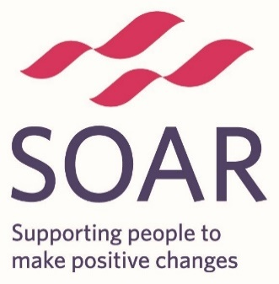

**Let’s Chat About Dementia**

Come and have a free cup of tea and a chat in the cafe with Rosie, SOAR’s Dementia Worker.

**Wednesdays 28th June, 26th July**

**13:00pm – 2:30pm**

**High Green Development Trust, The Campus, Pack Horse Lane, Sheffield, S35 3HY**

Rosie – 07538 100 375  
[rosie.strathearn@soarcommunity.org.uk](mailto:rosie.strathearn@soarcommunity.org.uk)



